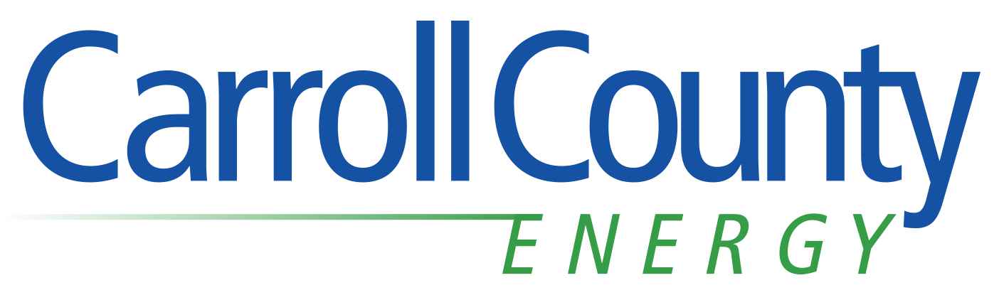
For Immediate Release (July 8, 2013)

Carroll County Energy Will Develop
State-of-Art Electric Generating Facility

CARROLLTON, Ohio (July 8, 2013) – Carroll County Energy LLC announced today that it intends to build a 700-megawatt natural gas electric generating facility to efficiently supply enough energy to provide electricity to 700,000 homes.

Carroll County Energy represents an important step forward in America’s transition to cleaner energy production and while maintaining energy independence. The electric generating facility is also expected to be a significant stimulus for the economy of Carroll County and surrounding communities.

The project is an $800 million capital investment that will provide up to 500 construction jobs. When completed, the facility will employ 25-30 full-time employees in well-paying engineering, technical, operation, management and administrative positions. The proposed facility is on 77 acres of land that is part of a 233-acre farm. The site is approximately one-half mile east of Ohio 9 and 2.5 miles north of Carrollton; it is adjacent Carroll County Community Improvement Corp. land that is designated for industrial and commercial development.

“With Ohio’s electricity needs continuing to grow and some 5,800 megawatts of conventional coal-fired power plants scheduled for retirement by the end of 2015 in Ohio, Carroll County Energy will help fill our generation needs with clean American natural gas,” said Jonathan Winslow, project manager for Carroll County Energy. “This facility can be aptly described as ‘efficient generation from a small footprint’.”

Advanced Power Services has an agreement with GE Energy to develop facilities using GE’s highly flexible and efficient gas turbine technology.

The facility will employ new state-of-the-art General Electric natural gas and steam turbine technology in a configuration referred to as “combined-cycle.” This configuration captures waste heat and generates additional electricity. The facility will produce 50 percent of the carbon dioxide and less than 10 percent of the sulfur dioxide and nitrogen dioxide that a conventional coal-fired power plant produces to generate the same electricity.

Significant economic benefits are expected as a result of the project. Winslow noted the company could enter an Enterprise Zone Agreement that would provide, long-term, stable tax revenues that would benefit Carroll County schools and other programs. He also noted significant economic benefits could result from purchases of goods and services, including payments for water and sewer services.

Winslow said the project is in the process of completing environmental studies and will be applying for and obtaining the necessary permits. Several open houses will be announced in the coming months for people to learn more about the project and the company soon will have additional information available at www.carrollcountyenergy.com.

Carroll County Energy is a subsidiary of Advanced Power Services (NA) Inc., a leading energy development company based in Boston, Mass. Advanced Power’s management has a proven track record of developing more than 9,400 megawatts of power generation projects worldwide.

# # #

Contact: Jon Winslow, 617-456-2208
jwinslow@advancedpowerna.com

Media: Jack Wollitz, 800-460-4111 ext. 8153
jack@innismaggiore.com

